string + string → helloworld
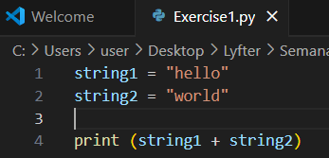
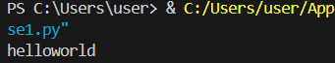
string + int → TypeError: can only concatenate str (not "int") to str
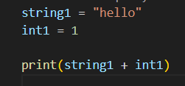
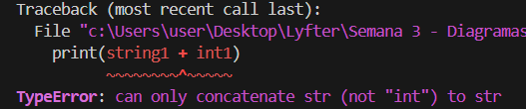
int + string → TypeError: unsupported operand type(s) for +: 'int' and 'str'
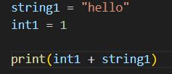
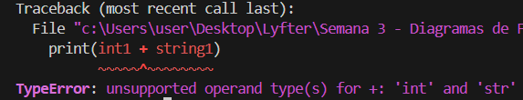
list + list →
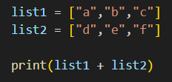
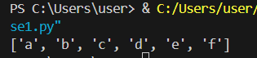

string + list → TypeError: can only concatenate str (not "list") to str
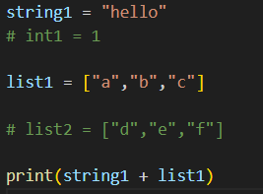
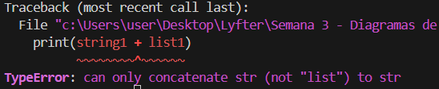
float + int →
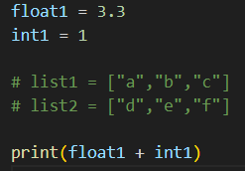
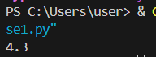
bool + bool
